STUDY GUIDE CHAPTER 7 pages 117-138
Read the assigned pages in the text, then hand write your responses.

- Define the term “biological diversity” or biodiversity for short.

- Briefly summarize the 8 reasons why people value nature (or biodiversity)

- Think: Describe TWO ecosystem (public) services provided to humans by forests. Explain how clear cutting (removing all trees) would affect each ecosystem service you describe.

- According to the theory of evolution, how do new species evolve?

- Compare and contrast the ways in which mutation, natural selection, migration and genetic drift lead to evolution and biodiversity.

6. Define the terms: a) adaptive radiation

b) founder effect
7. Read ‘A Closer Look 7.1’. Describe, in detail, the process of DDT pesticide resistance in mosquitoes, an example of biological evolution today.

8. Examine the scenario below. Then answer the questions that follow (requires thinking on your own)
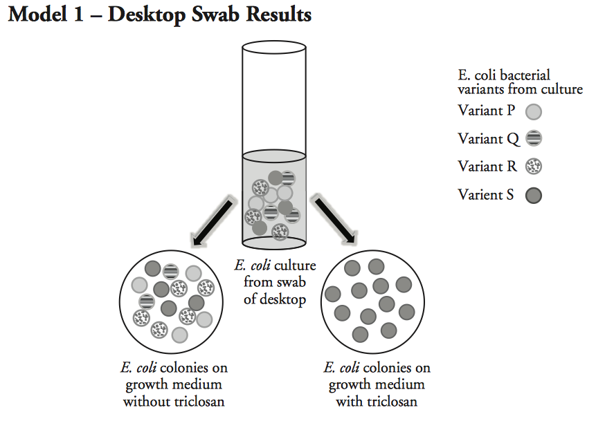
- What is the source of the bacteria in the culture tube in Model 1?
- How many genetic variants of E.coli were present in the culture from the initial swab?

- What variants of E.coli are found on the dish grown without triclosan?

- Refer to the dish in Model 1 with the medium that included triclosan.
  - What variants of E.coli are found on the dish grown with triclosan?
  - What likely happened to the other variants of E.coli on the dish with the medium containing triclosan?

v. Based on its effect on E.coli, why is triclosan used as a cleaning agent?
- Suppose the desktop swabbed earlier was cleaned with a solution containing triclosan. Would living E.coli remain? Support your answer.

- Suppose the desktop was swabbed again after cleaning it with triclosan over a 9-month school year. When the sample was cultured only variant S was seen.
  - What characteristic does the variant S bacteria have that allows it to remain on the desktop even after several months of treatment with triclosan?

  - Is it likely that the bacteria in the new swab were on the desk 9-months ago, or are they off- spring of the original bacteria?

  - Propose an explanation for the presence of only variant S on the desktop after so much time.

9. How is genetic diversity different than habitat diversity?

10. Species diversity is more difficult to measure and is described by three qualities: richness, evenness and dominance. Identify the quality being described in each statement below.
a) “the simplest way to describe a community is to list the species in it”
b) “the probability of two animals, picked at random from a forest, being of the same species”
c) “the relative distribution of individuals among species”
11. Leave this chapter for now and turn to page 267-268: A closer look 14.1. Present 5 arguments in favor of the maintenance of biodiversity. At least 3 of them should be utilitarian.

12. Return to page 126, section 7.4, The Evolution of Life on Earth. How did the earliest life forms alter the chemistry of the atmosphere? Be specific!

13. What 4 ‘innovations’ does the text suggest had to evolve for life to thrive on land (as opposed to remaining in the oceans)?

14. Which two “inventions” allowed reptiles to become land dwelling animals?

15. Identify two “inventions” that allowed mammals to occupy so many terrestrial niches today.

16. How many species exist on the Earth today? Why is this number only an estimate?

17. Identify the 5 kingdoms of life, as classified by the scientific community.

18. Which animal species dominates the earth in terms of diversity? Which is the least numerous?

19. Describe each of the following interactions among species:
(i) competition
(ii) symbiosis
(iii) parasitism
20. How does the introduction of the gray squirrel in Britain illustrate the one way that humans cause a threat to biodiversity? Describe.

21. Millions of species coexist because of the competitive exclusion principle. Explain how flour beetles exemplify the edict that species requiring the same resources can coexist only by utilizing those resources under different environmental conditions.

22. What is the difference between habitat and niche?

23. Distinguish between fundamental and realized niches.

24. How does predation increase biodiversity?

25. Think: a city park manager has run out of money to buy new plants. How can the park labor force ALONE be used to increase the diversity of birds in the park? Explain your reasoning.

